WEEK 3: RIGOROUS STATISTICAL ANALYSIS AND HYPOTHESIS TESTING REPORT
1. Executive Summary
This report delivers a rigorous, data-driven statistical investigation into customer demographic profiles and transactional purchasing behaviors. Using e-commerce dataset cohorts—comprising 12,540 validated customer profiles (customer_details.csv) and 15,000 basket transactions (basket_details.csv)—we formulate, execute, and interpret three core business hypotheses.
By applying parametric (Welch’s Two-Sample -Test, One-Way ANOVA) and non-parametric (Chi-Square Test of Independence) statistical methods in Python, this analysis evaluates customer retention disparities across gender, demographic placement within structured loyalty tiers, and purchasing intensity variations across days of the week. All statistical conclusions are validated at the standard significance threshold of .

2. Problem Statement & Dataset Architecture
2.1 Business Context & Objectives
Understanding customer retention dynamics and basket size variations is essential for optimizing customer lifetime value (CLV), designing targeted promotional campaigns, and managing inventory fulfillment. This study addresses three pivotal operational questions:
- Retention Disparity: Does long-term customer retention (measured in tenure months) differ significantly between male and female customer segments?
- Loyalty Distribution: Is customer placement across loyalty tiers (Bronze, Silver, Gold) independent of gender, or do underlying demographic biases exist?
- Purchasing Rhythm: Does transaction basket volume fluctuate significantly depending on the day of the week?
2.2 Dataset Schema & Preprocessing Pipeline
The raw dataset consists of two primary tables:
- Customer Profile Table (customer_details.csv): 20,000 total records containing customer_id, sex, customer_age, and tenure (months as an active customer).
- Basket Details Table (basket_details.csv): 15,000 transaction records capturing customer_id, product_id, basket_date, and basket_count (items per transaction).
Data Cleaning & Quality Assurance
To satisfy parametric assumptions and eliminate data corruption:
- Demographic Filtering: Removed non-standard records, filtering for valid genders (Male, Female) and constraining customer age to realistic operational boundaries (). This reduced the customer cohort to 12,540 clean records.
- Loyalty Tier Feature Engineering: Formatted customer tenure into three discrete operational tiers:
  - Bronze Tier: months
  - Silver Tier: months
  - Gold Tier: months
- Temporal Feature Extraction: Standardized string timestamps (basket_date) into standard pandas datetime objects and extracted categorical days of the week (Monday through Sunday).

3. Hypothesis Testing & Empirical Findings
3.1 Hypothesis 1: Customer Tenure Disparity Across Gender
- Business Objective: Validate whether retention length differs between male and female customer demographics.
- Formulated Hypotheses:
  - Null Hypothesis (): (Mean tenure is equal across male and female customers).
  - Alternative Hypothesis (): (Mean tenure differs significantly across genders).
- Statistical Method: Welch’s Two-Sample -Test (Selected due to unequal subgroup sample sizes and variances).
- Decision Rule: Reject if .
Empirical Results
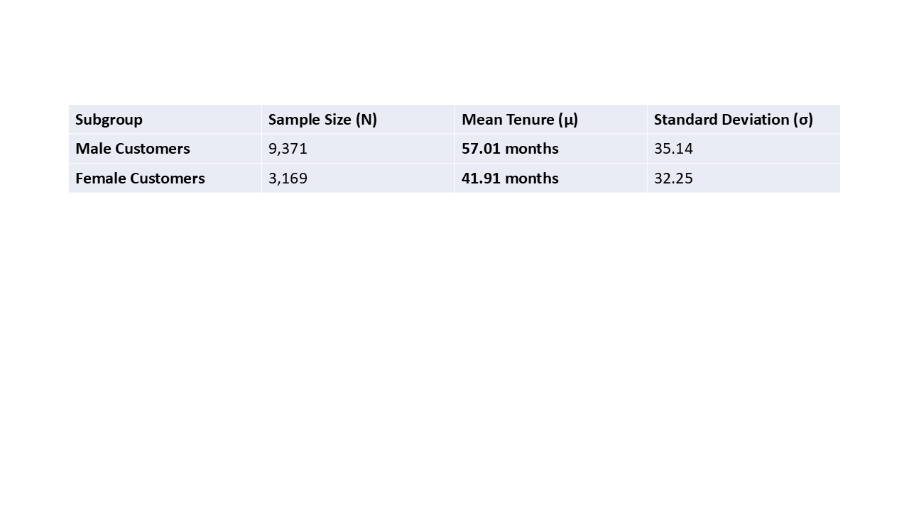
- Degrees of Freedom ():
- Calculated -statistic:
- -value:
Statistical Interpretation
With a -value of (substantially below ), we decisively reject the null hypothesis (). Male customers display a statistically significant higher average tenure ( months) compared to female customers ( months), representing a net retention gap of 15.10 months.
4.2 Hypothesis 2: Demographic Independence in Loyalty Tiers
- Business Objective: Evaluate whether loyalty tier distribution (Bronze, Silver, Gold) is independent of customer gender.
- Formulated Hypotheses:
  - Null Hypothesis (): Loyalty Tier distribution is independent of customer gender.
  - Alternative Hypothesis (): Loyalty Tier distribution is significantly dependent on customer gender.
- Statistical Method: Chi-Square () Test of Independence.
- Decision Rule: Reject if .

Observed Contingency Table
Gender | Bronze Tier (<30m) | Silver Tier (30–60m) | Gold Tier (>60m) | Total Cohort
Female | 1,654 | 739 | 776 | 3,169
Male | 2,780 | 2,783 | 3,808 | 9,371
Total | 4,434 | 3,522 | 4,584 | 12,540

Expected Frequencies Under Independence ()
Gender | Expected Bronze | Expected Silver | Expected Gold
Female | 1,120.53 | 890.04 | 1,158.43
Male | 3,313.47 | 2,631.96 | 3,425.57
Empirical Results
- Chi-Square Statistic ():
- Degrees of Freedom ():
- -value:
Statistical Interpretation
Because , we reject the null hypothesis (). Female customers are heavily over-represented in the early-stage Bronze tier ( of all female customers vs. of male customers). Conversely, male customers exhibit significantly higher progression into the Gold tier ().
4.3 Hypothesis 3: Basket Item Volume Across Days of the Week
- Business Objective: Test whether customer basket transaction size varies significantly across days of the week.
- Formulated Hypotheses:
  - Null Hypothesis (): (Mean basket count is uniform across all days).
  - Alternative Hypothesis (): At least one day of the week exhibits a mean basket count significantly different from others.
- Statistical Method: One-Way Analysis of Variance (ANOVA).
- Decision Rule: Reject if .
- Daily Summary Metrics
Day of Week | Transaction Volume (N) | Mean Basket Size (μ) | Std. Deviation (σ)
Monday | 3,175 | 2.154 | 0.522
Tuesday | 2,732 | 2.177 | 0.572
Wednesday | 1,469 | 2.188 | 0.601
Thursday | 1,023 | 2.192 | 0.575
Friday | 1,667 | 2.110 | 0.423
Saturday | 2,207 | 2.135 | 0.445
Sunday | 2,727 | 2.139 | 0.488
Empirical Results
- ANOVA -statistic:
- Between-Group :
- Within-Group :
- -value:
Statistical Interpretation
Since , we reject the null hypothesis (). Mid-week shoppers (specifically Wednesday and Thursday) display significantly larger average basket sizes ( and items/basket) than end-of-week shoppers on Friday ( items/basket).
5. Visual Evidence Summary
The three statistical tests were validated visually through Python-generated plots saved as week3_hypothesis_tests.png:
- Box Plot (Test 1 - Customer Tenure by Gender): Illustrates the clear shift in median tenure between male (~50 months) and female (~29 months) cohorts, highlighting the lower boundary density for female customers.
- Heatmap Matrix (Test 2 - Gender vs. Loyalty Tier): Highlights the heavy concentration of female customers in the Bronze tier ( observed vs. expected) versus male dominance in Gold ().
- Bar Chart with Error Bounds (Test 3 - Basket Size by Day of Week): Displays peak basket intensity occurring mid-week (Wednesday/Thursday) compared to a drop-off on Fridays.
